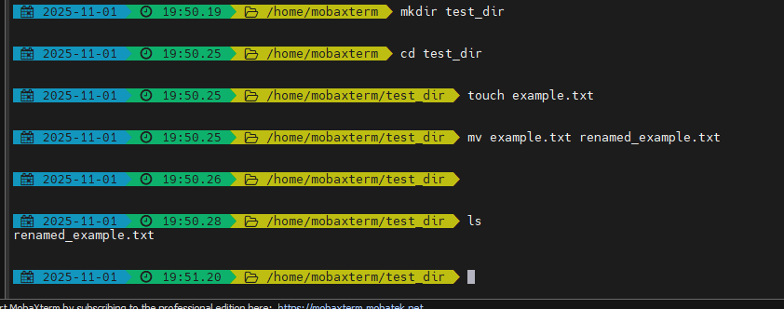
Explanation:
- mkdir test_dir → Creates a new directory named test_dir.
- touch example.txt → Creates an empty file named example.txt inside test_dir.
- mv example.txt renamed_example.txt → Renames the file.

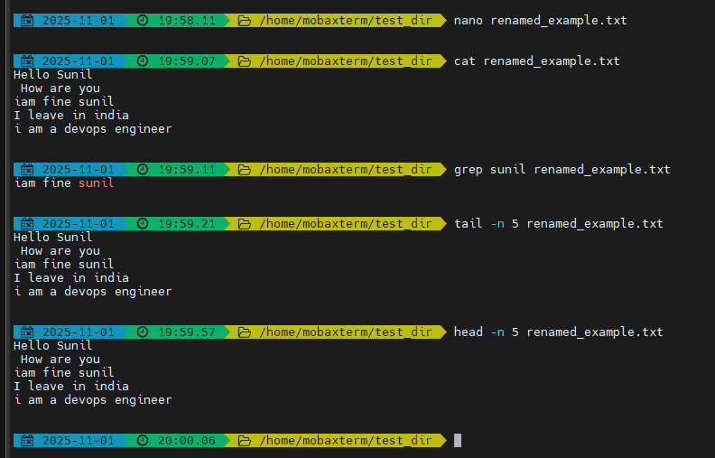
• cat displays the entire file.
• head -n 5 shows the first 5 lines.
• tail -n 5 shows the last 5 lines.
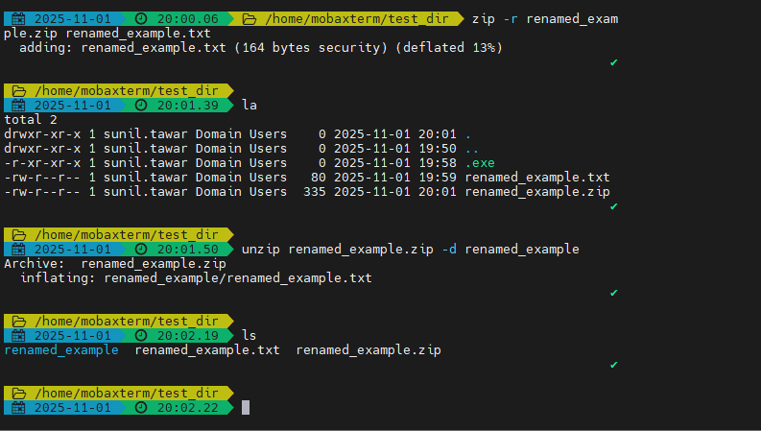
• zip -r compresses the folder into a .zip file.
• unzip extracts it into a new directory called unzipped_dir.

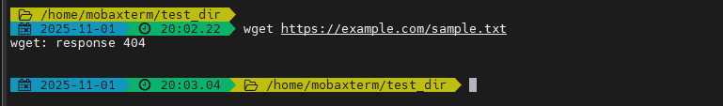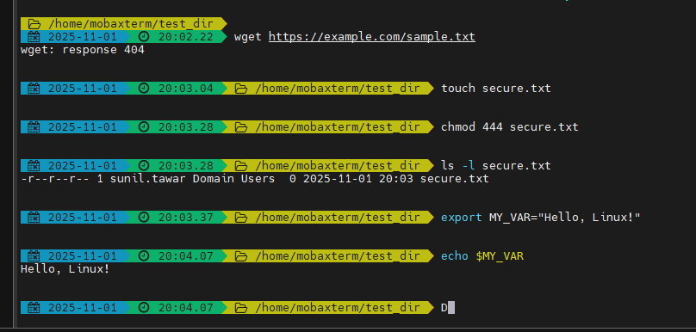
wget is used to download files from the internet using a URL.
chmod 444 sets read-only permissions for everyone.
• export creates a new environment variable.
• echo displays its value.

